Daily Tip 33 13/06/2003 10:15:00 AM

Area charts which can compare magnitudes of variables in categories
The GAREABAR procedure in SAS/Graph lets you compare the magnitudes of 2 variables for each category of data using exact and relative magnitudes of values. It only works with ODS using the activex or actimgx driver though.
The following example plots sales on the x-axis, relative percent of number of salespersons on the y-axis, with a bar for each site. Additionally each bar is sub-grouped by quarter.
Proc gAreaBar - http://v9doc.sas.com/cgi-bin/sasdoc/cgigdoc?file=../graphref.hlp/a002252885.htm

SAS Log
goptions reset=all device=activex ;

ods html file='c:\test.html' ;

data totals;
input Site $ Quarter $ Sales Salespersons;
cards;
Lima 1 4043.97 4
NY 1 4225.26 12
Rome 1 16543.97 6
Lima 2 3723.44 5
NY 2 4595.07 18
Rome 2 2558.29 10
Lima 3 4437.96 8
NY 3 5847.91 24
Rome 3 3789.85 14
Lima 4 6065.57 10
NY 4 23388.51 26
Rome 4 1509.08 16
;
proc gareabar data=totals;
hbar site*salespersons /sumvar=sales
subgroup=quarter
rstat=SUM
wstat=PCT;
run ; quit ;

ods html close;
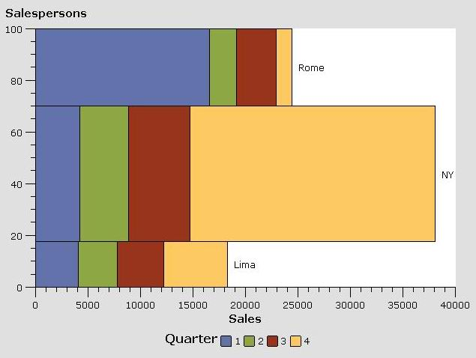
Example tested under SAS 9.0, Windows 2000 by Phil Mason
Wood Street Consultants Ltd. tips@woodstreet.org.uk
www.woodstreet.org.uk

